**Fake news detection system**

Kshitij Adesh Jadhav

Date - 22/08/23

**Abstract**

Fake news and hoaxes have been there since before the advent of the Internet. The widely accepted definition of Internet fake news is: fictitious articles deliberately fabricated to deceive readers. Social media and news outlets publish fake news to increase readership or as part of psychological warfare. In general, the goal is profiting through clickbaits. Clickbaits lure users and entice curiosity with flashy headlines or designs to click links to increase advertisements revenues. This exposition analyzes the prevalence of fake news in light of the advances in communication made possible by the emergence of social networking sites. The purpose of the work is to come up with a solution that can be utilized by users to detect and filter out sites containing false and misleading information. We use simple and carefully selected features of the title and post to accurately identify fake posts. The experimental results show a 99.4% accuracy using logistic classifier.

**Introduction**

The idea of fake news is not a novel concept. Notably, the idea has been in existence even before the emergence of the Internet as publishers used false and misleading information to further their interests. Following the advent of the web, more and more consumers began forsaking the traditional media channels used to disseminate information for online platforms . Not only does the latter alternative allow users to access a variety of publications in one sitting, but it is also more convenience and faster. The development, however, came with a redefined concept of fake news as content publishers began using what has come to be commonly referred to as a clickbait. Clickbaits are phrases that are designed to attract the attention of a user who, upon clicking on the link, is directed to a web page whose content is considerably below their expectations. Many users find clickbaits to be an irritation, and the result is that most of such individuals only end up spending a very short time visiting such sites.

For content publishers, however, more clicks translate into more revenues as the commercial aspect of using online advertisements is highly contingent on web traffic. As such, despite the concerns that have been raised by readers about the use of clickbaits and the whole idea of publishing misleading information, there has been little effort on the part of content publishers to refrain from doing so.

1. **Problem Statement**

The problem statement is to create a Fake news detection system using machine learning which can detect fake news from real news. Imagine a scenario where a false news story spreads rapidly on social media, claiming that a particular medication is a cure for a deadly disease. People start hoarding the medication, causing scarcity and preventing those who need it from accessing it. This example scenario shows one of the several real-world risks of fake news.

1. **Proposed solution**

The proposed solution to the issue concerned with fake news includes the use of a tool that can identify and remove fake sites from the results provided to a user by a search engine or a social media news feed. The tool can be downloaded by the user and, subsequently, be appended to the browser or application used to receive news feeds. Once operational, the tool will use various techniques including those related to the syntactic features of a link to determine whether the same should be included as part of the search results.

1. **Customer need Assessment**

Customers can filter out all the fake news efficiently with a properly developed detection app. The app can be easier to navigate due to its user friendly UI. Price won’t be an issue since this detection app is free of cost. Almost every single customer prefer to watch online news, hence its easier to misdirect them into believing some fake piece of information through such online platform. Hence, a browser extension of such a detection system can put an end to such online scams.

1. **Target Specification**

Fake news detection system can help every single person to see through fake news and prevent a mass chaos. It uses Machine Learning to distinguish between true news and false news by analyzing patterns in the language and sources used in news reports. This application makes use of a large data set to ensure that an accurate predictive model is built. This in turn helps us to find fake news from real news.

1. **Overview of Fake news detection**

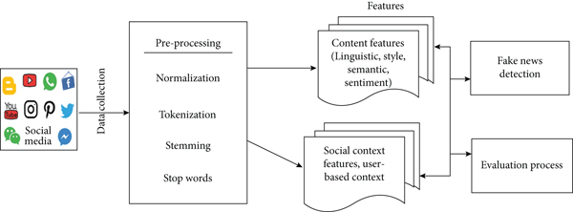

1. **Fake news detection Taxonomy**

We spend so much time online that individuals choose social media news sources over conventional news sources. In this section, we present the taxonomy for fake news detection. Below figure shows the taxonomy for fake news detection.

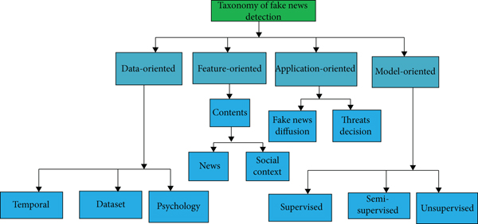

**5.1 Data-oriented**

Various types of data features, including dataset, temporal, and psychological, are being studied in data-driven fake news studies. Researchers have showed that there is no existing benchmark dataset that provides resources for extracting all essential attributes. To facilitate future studies on this topic, we create a comprehensive and large-scale benchmark dataset for false news. This is a possible technique. The spread of fake news on social media follows different temporal patterns that differ from that of legitimate news. The job of early false news identification, which attempts to offer fake news warnings early rather than later in the distribution process, is thus fascinating. It is possible that detecting bogus news early on may assist to prevent it from spreading further on social media platforms.

**5.2 Feature-oriented**

False news research with a focus on features is aimed at uncovering valuable characteristics that may be used to distinguish true news from false news from some data sources. News content and the social environment are two significant data sources that have been shown. In terms of news content, researchers created linguistic and visual methodologies for extracting information from text data. However, although linguistic-based qualities have been extensively explored to aid with general NLP tasks such as text classification and grouping, the fundamental characteristics of false news remain unknown. Additionally, “embedding methods such as word embedding and deep neural networks are gaining popularity for textual feature extraction due to their ability to generate better representations and improve feature extraction accuracy”. It has also been shown that visual components taken from images may serve as key indications of bogus news. However, limited research has been undertaken to utilize important visual characteristics for the false news detection challenge, including classic local and global features and recently generated deep network-based features. Several sophisticated approaches have recently been shown, including the ability to edit video recordings of renowned persons, create high-quality films, and other skills. As a consequence, distinguishing true from false visual information becomes much more difficult and critical. Adding user-based, postbased, and network-based components to the system from the perspective of the social context is crucial. Existing user-based features are mostly focused on broad user profiles rather than distinguishing across numerous account types and obtaining user-specific attributes from each of them. Others, such as convolutional neural networks (CNN), might be used to represent postbased attributes to better capture people’s thoughts and reactions to bogus news.

**5.3 Application-oriented**

The term “application-oriented fake news” refers to a study that extends beyond the identification of fake news. Along these lines, we suggest two key approaches: false news dissemination and fake news intervention. Regarding fake news distribution on social media networks, false news diffusion outlines the pathways and patterns of false news dissemination. In the early stages of the study, it was discovered that authentic information and misinformation spread in very different ways on online social networks. Similarly, the dissemination of bogus news on social media has particular features that require more examination, such as sociodemographic characteristics, life cycles, and transmitter detection. Among different social groups, social dimensions are defined as the variety and weak reliance on social ties within each grouping. Because their friends on social media who have the same views as they do influence consumers’ impressions of fake news (i.e., echo chambers), users’ perceptions of false news vary across different social dimensions. Because of this, it is interesting to explore why and how diverse societal aspects contribute to the dissemination of incorrect information across a variety of areas such as politics, education, athletics, and other fields of interest. People’s attention and emotions are drawn to the fake news broadcast process at various stages along the process, which culminates in a unique life cycle. Breaking news and more in-depth news have different life cycles, according to social media studies. Users who have already been influenced by fake news should be immunized with factual information to modify their beliefs. Removing harmful accounts that spread misleading information or fake news is a primary goal of proactive intervention tactics for combating fake news.

**5.4 Model-oriented**

Modeling-based fake news research provides the door for the creation of more effective and practical techniques for detecting and preventing false news from spreading. It has been detailed in the previous sections how different characteristics may be extracted and included in classification models such as Random Forest, decision trees, logistic regression and then recommended the correct classifiers from all these frameworks. Developing more complex models and making greater use of the retrieved characteristics will need additional investigation. The creation of the aggregation approach, the probabilistic method, ensemble method, and projection method are some examples. Algorithms that integrate many feature representations into a weighted form and maximize the weights of each feature are called aggregation algorithms in the beginning. Because fake news usually contains both genuine and incorrect assertions, probabilistic models may be a better choice for predicting the possibility of it being fake news than just providing a binary value. Class labels (such as false vs. genuine news) may be predicted by using the same distribution of features that were used to store them in the first place. Each factor, such as the reliability of the source, the nature of the news, or the response of the public, has unique limits in terms of accurately anticipating false news on its own, making it very difficult to detect false news. Combining several weak classifiers into a single strong classifier is the goal of ensemble approaches, which have been widely used in the machine learning literature for a wide range of applications.

1. **External search**

A large number of different fake news datasets are accessible because of the many academics working on this subject; however, only a few benchmark fake news datasets are published in the media.Following is the [data set](https://drive.google.com/file/d/1q5jpI5M1EA9x3YPrLupmiu3gffkmGlHj/view) used for the fake detection system -

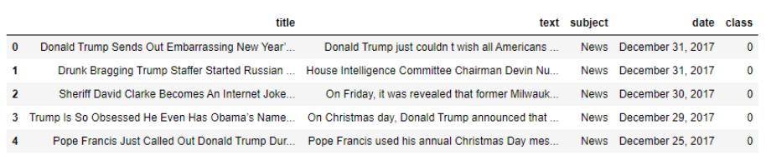

The above mentioned data set has a total of 44919 rows and 5 columns. It doesn’t have any null values. Since the columns “title”, “subject” and “date” are of no use for further model building, they can be dropped.

* 1. **Benchmarking**

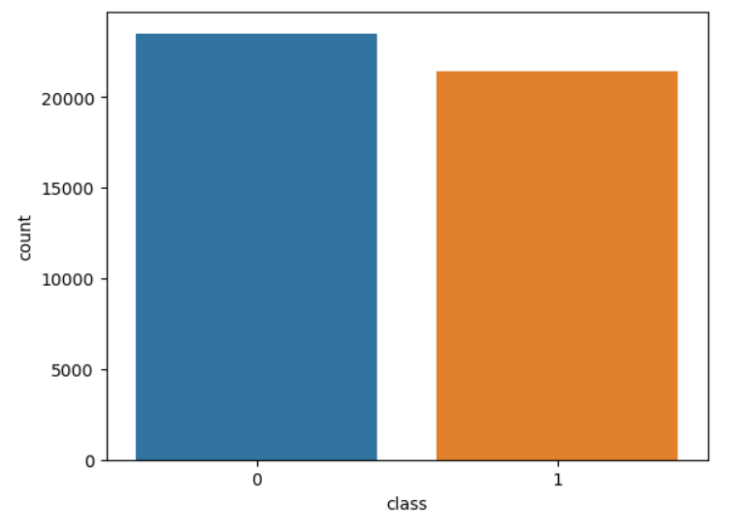

Above diagram is a countplot which shows the total number of class 0 and class 1.

**Wordcloud**

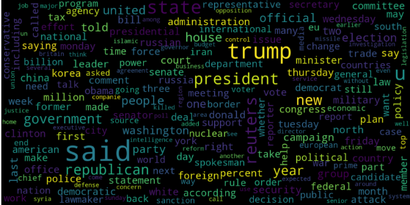

Above is the Wordcloud for **fake** news

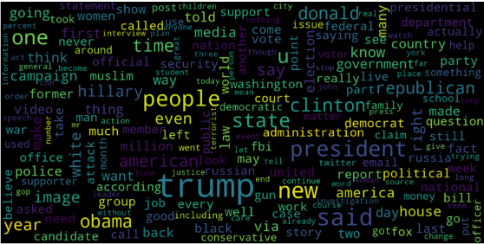

Above is the Wordcloud for **real** news

**Barchart**

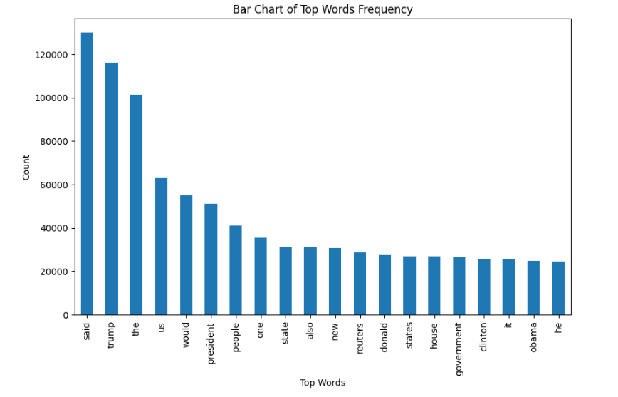

* 1. **Fake news detection Algorithm**

The creation of algorithms focuses on the logic behind cross-layer detection optimization principles. An enhanced detection strategy is suggested in some levels of the model. The identification is being done to create a flag that would warn consumers of the potential of reading bogus news online. The algorithm checks the database to ensure the website’s legitimacy. If the relevant result is discovered or not found, it will be returned.

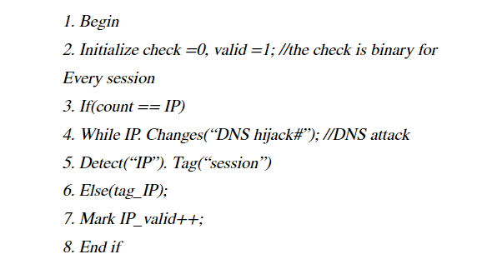

1. **Concept Generation**

This product requires the tool of machine learning models to be written

from scratch in order to suit our needs. . Tweaking these models for our use is

less daunting than coding it up from scratch. A well trained model can either

be repurposed or built. But building a model with the resources and data we

have is dilatory but possible. The customer might want to spend the least

amount of time giving input data. . This accuracy will take a little effort to nail,

because it’s imprudent to rely purely on Classic Machine Learning algorithm.

**6.1**  **Splitting the data into train and test**

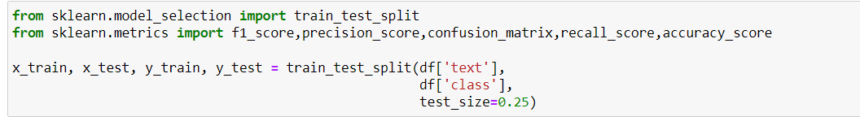

**6.2 Applying Vectorization on the data**

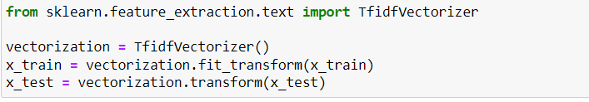

**6.3 Training the data using different predictive models**

**Logistic Regression**

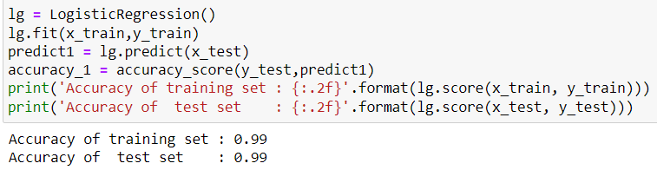

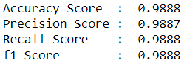

**Decision Tree Classifier**

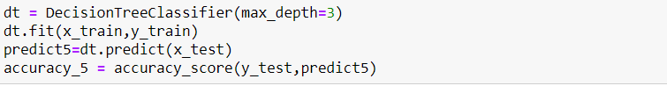

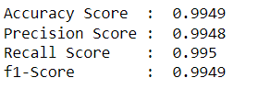

**Random Forest Classifier**

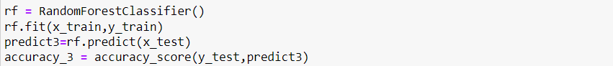

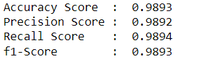

1. **Model Evaluation**

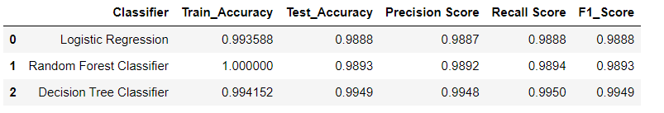

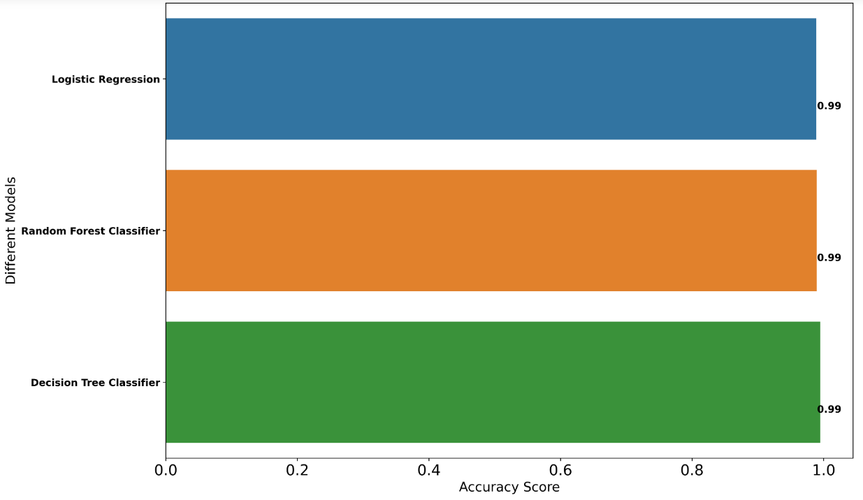

From the above diagrams, out of those three models, the overall score of **Decision Tree Classifier** model is better than others. Hence, we can finalize it.

1. **Concept Development**

The concept can be developed by using the appropriate API (flask in this

case) and using Django as framework for the same and for its deployment , the

cloud services has to be chosen accordingly.

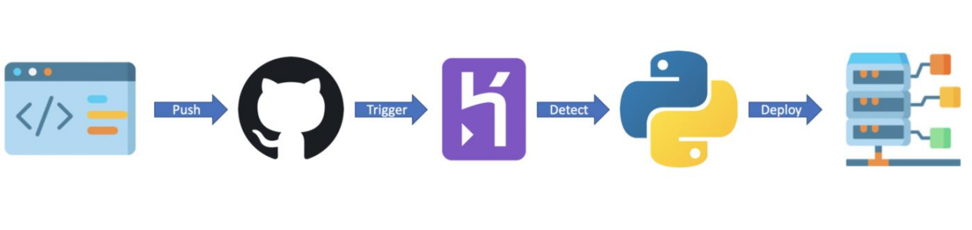

1. **Final Report Prototype**

The product takes the following functions to perfect and provide a good result.

**Back end**

Model Development:

This must be done before releasing the service. A lot of manual supervised

machine learning must be performed to optimize the automated tasks.

1. Performing EDA to realize the dependent and independent features.

2. Algorithm training and optimization must be done to minimize over fitting of the model and hyperparameter tuning.

**Front End**

1. Different user interface: The user must be given many options to choose form in terms of parameters. This can only be optimized after a lot of testing and analysis all the edge cases.

2. Interactive visualization the data extracted from the trained models will return raw and inscrutable data. This must be present in an aesthetic and an “easy to read” style.

3. Feedback system: A valuable feedback system must be developed to understand the customer’s needs that have not been met. This will help us train the models constantly.

1. **Code Implementation**

**[This is the Github link](https://github.com/Kshitij-2107/Fake-news-detection-system-Feynn-labs-internship-.git)**

1. **Conclusions**

Fake news and Clickbaits interfere with the ability of a user to discern useful information from the Internet services especially when news becomes critical for decision making. Considering the changing landscape of the modern business world, the issue of fake news has become more than just a marketing problem as it warrants serious efforts from security researchers. It is imperative that any attempts to manipulate or troll the Internet through fake news or Clickbaits are countered with absolute effectiveness. We proposed a simple but effective approach to allow users install a simple tool into their personal browser and use it to detect and filter out potential Clickbaits. The preliminary experimental results conducted to assess the method’s ability to attain its intended objective, showed outstanding performance in identify possible sources of fake news. Since we started this work, few fake news databases have been made available and we’re currently expanding our approach using R to test its effectiveness against the new datasets.

1. **References**

<https://www.hindawi.com/journals/wcmc/2022/6072084/#abstract>

<https://drive.google.com/file/d/1q5jpI5M1EA9x3YPrLupmiu3gffkmGlHj/view>

[http://arxiv.org/abs/2102.13433](http://arxiv.org/abs/2102.13433" \t "https://www.hindawi.com/journals/wcmc/2022/6072084/_blank)

https://www.projectpro.io/article/fake-news-detection-project/854